**Practical 10**

**Case Study – Microsoft Azure**

**Introduction:**

Microsoft Azure (formerly Windows Azure) is a [cloud computing](https://en.wikipedia.org/wiki/Cloud_computing) service created by [Microsoft](https://en.wikipedia.org/wiki/Microsoft) for building, testing, deploying, and managing applications and services through Microsoft-managed [data centers](https://en.wikipedia.org/wiki/Data_center). It provides [software as a service (SaaS)](https://en.wikipedia.org/wiki/Software_as_a_service), [platform as a service (PaaS)](https://en.wikipedia.org/wiki/Platform_as_a_service) and [infrastructure as a service (IaaS)](https://en.wikipedia.org/wiki/Infrastructure_as_a_service) and supports many different [programming languages](https://en.wikipedia.org/wiki/Programming_language), tools and frameworks, including both Microsoft-specific and third-party software and systems.

Azure was announced in October 2008, started with codename "Project Red Dog",[[1]](https://en.wikipedia.org/wiki/Microsoft_Azure#cite_note-1) and released on February 1, 2010, as "Windows Azure" before being renamed "Microsoft Azure" on March 25, 2014

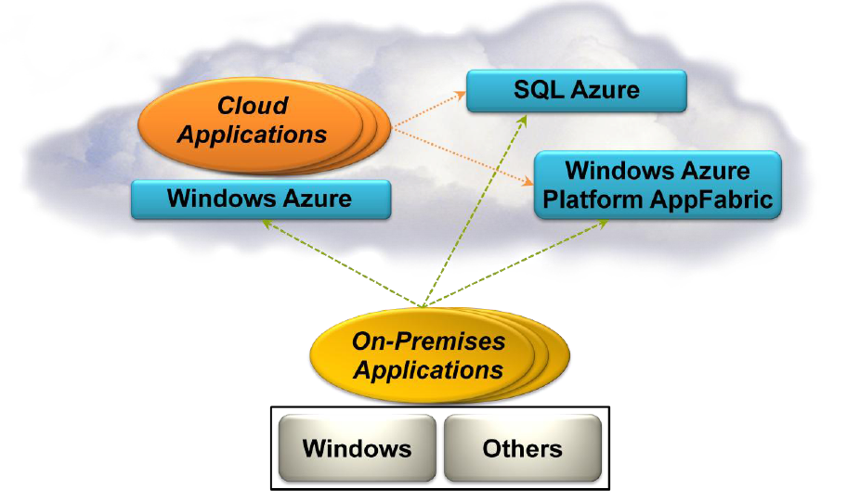

**Execution Environment:**

The Windows Azure execution environment consists of a platform for applications and services hosted within one or more roles. The types of roles you can implement in Windows Azure are:

* **Azure Compute (Web and Worker Roles).**

A Windows Azure application consists of one or more hosted roles running within the Azure data centers. Typically there will be at least one Web role that is exposed for access by users of the application. The application may contain additional roles, including Worker roles that are typically used to perform background processing and support tasks for Web roles.

* **Virtual Machine (VM role).**

This role allows you to host your own custom instance of the Windows Server 2008 R2 Enterprise or Windows Server 2008 R2 Standard operating system within a Windows Azure data center.

**Data Management:**

Windows Azure, SQL Azure, and the associated services provide opportunities for storing and managing data in a range of ways. The following data management services and features are available:

**Azure Storage:**

This provides four core services for persistent and durable data storage in the cloud. The services support a REST interface that can be accessed from within Azure-hosted or on-premises (remote) applications.

* **The Azure Table Service** provides a table-structured storage mechanism based on the familiar rows and columns format and supports queries for managing the data. It is primarily aimed at scenarios where large volumes of data must be stored, while being easy to access and update.
* **The Binary Large Object (BLOB)** Service provides a series of containers aimed at storing text or binary data. It provides both Block BLOB containers for streaming data, and Page BLOB containers for random read/write operations.
* **The Queue Service** provides a mechanism for reliable, persistent messaging between role instances, such as between a Web role and a Worker role.
* Windows Azure Drives provide a mechanism for applications to mount a single volume NTFS VHD as a Page BLOB, and upload and download VHDs via the BLOB.

**SQL Azure Database:**

 This is a highly available and scalable cloud database service built on SQL Server technologies, and supports the familiar T-SQL based relational database model. It can be used with applications hosted in Windows Azure, and with other applications running on-premises or hosted elsewhere.

**Data Synchronization:**

SQL Azure Data Sync is a cloud-based data synchronization service built on Microsoft Sync Framework technologies. It provides bi-directional data synchronization and data management capabilities allowing data to be easily shared between multiple SQL Azure databases and between on-premises and SQL Azure databases.

**Caching:**

This service provides a distributed, in-memory, low latency and high throughput application cache service that requires no installation or management, and dynamically increases and decreases the cache size automatically as required. It can be used to cache application data, ASP.NET session state information, and for ASP.NET page output caching.

**What you can do with Microsoft Azure?**

The following are just some of the vast plethora of ways we can use Azure:

* Reimagining an existing system, turning your idea into new app or creating a robust hybrid cloud application is all possible with Azure cloud.
* To make you successful, Azure has over 100 services with good end-to-end tools.
* Azure provides built-in support for patching, log analytics, monitoring and site recovery.
* If you are a database expert with SQL server then you can migrate to Azure with zero downtime.
* You can develop DevOps process using Visual Studio Team Services.
* With real time assembly line data you can use Azure Machine Learning to predict failures before they happen.
* Without a VPN one can securely access on-premises web applications.

**Networking Services:**

Windows Azure provides several networking services that you can take advantage of to maximize performance, implement authentication, and improve manageability of your hosted applications. These services include the following:

**Content Delivery Network (CDN).**

The CDN allows you to cache publicly available static data for applications at strategic locations that are closer (in network delivery terms) to end users. The CDN uses a number of data centers at many locations around the world, which store the data in BLOB storage that has anonymous access. These do not need to be locations where the application is actually running.

**Virtual Network Connect.**

This service allows you to configure roles of an application running in Windows Azure and computers on your on-premises network so that they appear to be on the same network. It uses a software agent running on the on-premises computer to establish an IPsec-protected connection to the Windows Azure roles in the cloud, and provides the capability to administer, manage, monitor, and debug the roles directly.

**Virtual Network Traffic Manager**.

This is a service that allows you to set up request redirection and load balancing based on three different methods. Typically you will use Traffic Manager to maximize performance by redirecting requests from users to the instance in the closest data center using the Performance method. Alternative load balancing methods available are Failover and Round Robin.

**Access Control.**

This is a standards-based service for identity and access control that makes use of a range of identity providers (IdPs) that can authenticate users. ACS acts as a Security Token Service (STS), or token issuer, and makes it easier to take advantage of federation authentication techniques where user identity is validated in a realm or domain other than that in which the application resides. An example is controlling user access based on an identity verified by an identity provider such as Windows Live ID or Google.

**Service Bus**.

This provides a secure messaging and data flow capability for distributed and hybrid applications, such as communication between Windows Azure hosted applications and on-premises applications and services, without requiring complex firewall and security infrastructures. It can use a range of communication and messaging protocols and patterns to provide delivery assurance, reliable messaging; can scale to accommodate varying loads; and can be integrated with on-premises BizTalk Server artifacts.

**Advantages of Microsoft Azure:**

Cloud computing has grown massively and is poised to grow likewise and on-premise infrastructure will essentially have no future. A few vital players have developed in the cloud computing circle, including Amazon Web Services (AWS), computing behemoth IBM, and Apple’s omnipresent iCloud. With such alternatives, why are organizations like 3M, BMW, Sapient Consulting, Bentley Systems, and GE moving workloads to Microsoft Azure? Let’s look at the reasons:

**Applications –** Microsoft makes creating and testing mission-critical applications effortless with offerings like Visual Studio Team Services, Visual Studio Application Insights and not forgetting Azure’s scalable, on-demand storage options for both most used and rarely used data. Microsoft likewise offers significant discounts on licensing if an individual or an organization wants to move their existing application to Azure.

**Disaster recovery –** Another preferred standpoint of Microsoft Azure lay in its rapid and topographically decentralized infrastructure, which is the reason behind storing multiple instances of the data. This is done for providing disaster recovery. This guarantees that any application and information can keep running from these multiple instances amid recovery periods that last minutes or hours rather than days. Hence Azure has all plans to render uninterrupted service even in times of untoward circumstances.

**Security –** Security Development Lifecycle (SDL) is key in providing security and privacy to Azure services. Azure is continually updated which makes it more secure as SDL looks after security aspects in each development phase. Operational Security Assurance (OSA) provides secure operations throughout the lifecycle of cloud-based services.

**Flexibility –** With Microsoft Azure you use new services and scale your data storage capabilities. Contrast this with a standalone on-premise data center, which would require fresh hardware and OS buying, provisioning, and deployment if huge IT requirements have to be met. This cutting edge adaptability makes Azure an enticing answer for firms of any size. One can pin the things that are important in their Azure dashboard.

**Cost –** Physical services and devices like load balancers, routers, computers can add huge dent in the finances of a company. On top of it consider the IT services required to run this hardware, which adds extra financial burden. Azure can greatly help in this regard and save precious amount on money which can otherwise be spent on furthering company’s interests.

**Azure pricing:**

One can save upto 72% if he commits to reserve VM instances for 1 to 3 years. This can of course be cancelled at anytime. One can also save upto 40% on virtual machines by using on-premises Windows Server licenses. There is no software charge on Microsoft virtual machines. There is significant developer/ testing pricing discounts for a host of Azure services.

We’ll see how different components are priced. We have taken the most popularly used Azure services.

|  |  |  |
| --- | --- | --- |
| **Component** | **Price (dollars)** | **Free services** |
| App Service | 0.01336/ hour | Free for first 12 months |
| Virtual machines | 0.01118/hour | Free for first 12 months |
| SQL databases | 0.02081/hour | 250GB free for the first 12 months |
| Blob | 0.01895/GB | 5GB free for the first 12 months |
| Azure Container Service | 0.01118/hour | Free for first 12 months |
| Functions | 0.2053/1 million executions | 1 million requests per month always free |